DM DASHBOARD

|  |  |
| --- | --- |
| DM Dashboard Page Details | |
| 1) | Contribution |
| 2) | Project Ranking |
| 3) | Variance |
| 4) | Billed Utilization |
| 5) | Charge Ratio |
| 6) | Cost |
| 7) | Milestone |
| 8) | Timelog |
| 9) | People Pyramid |
| 10) | Visa |
| 11) | Attrition |
| 12) | Base Data |
| 13) | FAQ |
| 14) | Summary page(Review is Pending from user) |

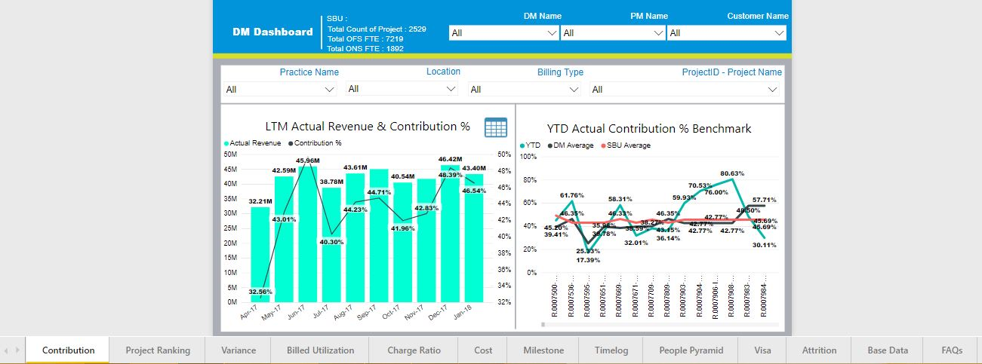

1. Contribution

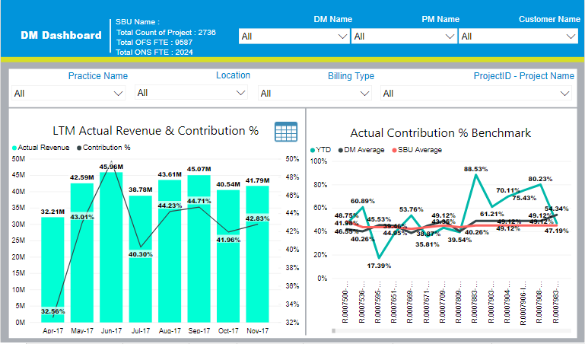

1. Project Ranking

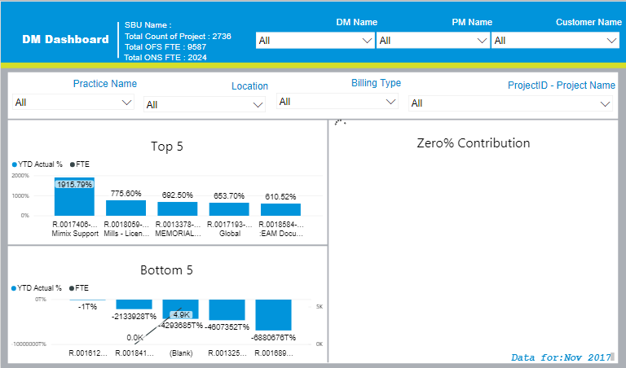

1. Variance

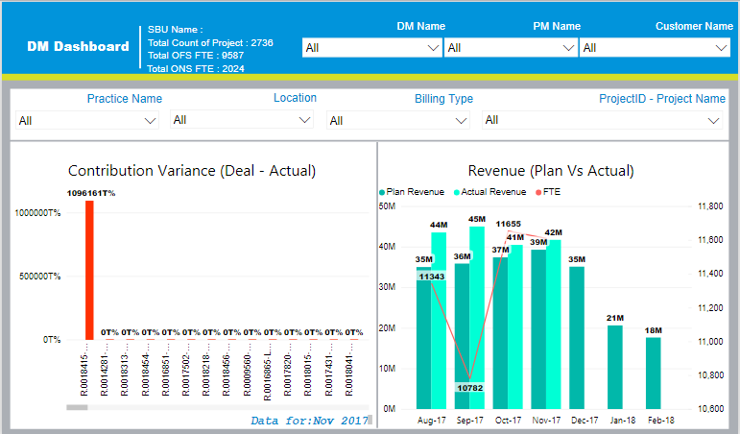

1. Billed Utilization

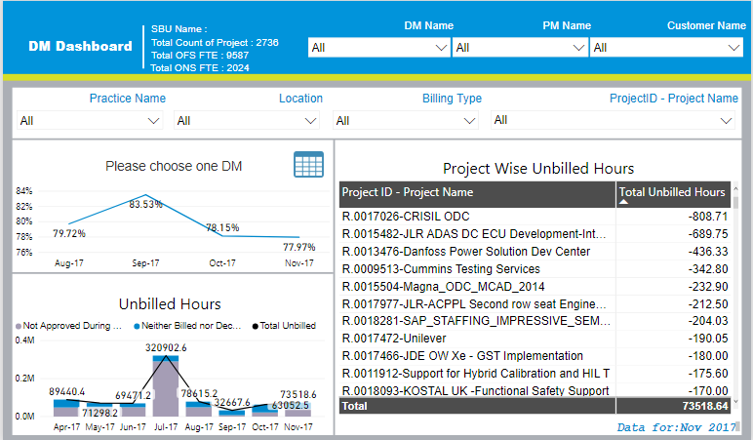

1. Charge Ratio

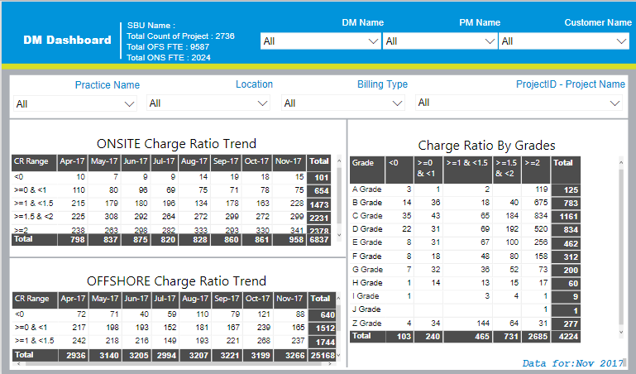

1. Cost

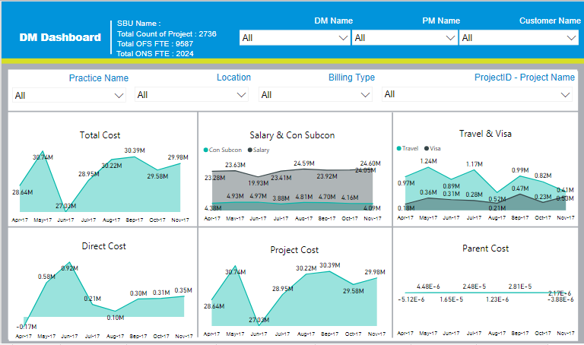

1. Milestone

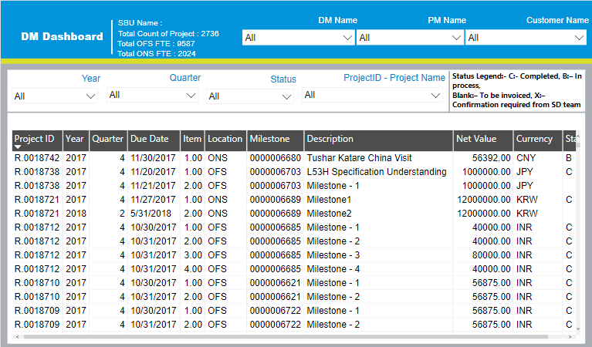

1. Timelog

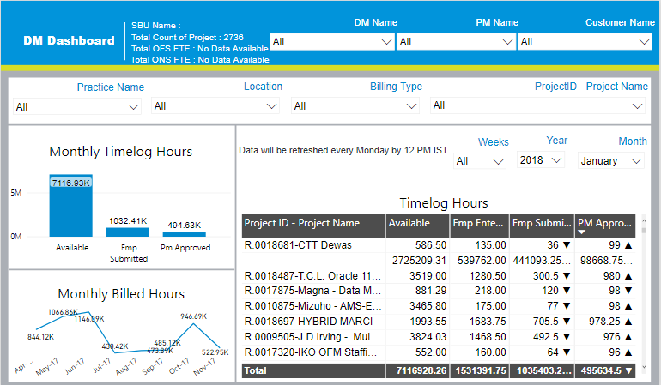

1. People Pyramid

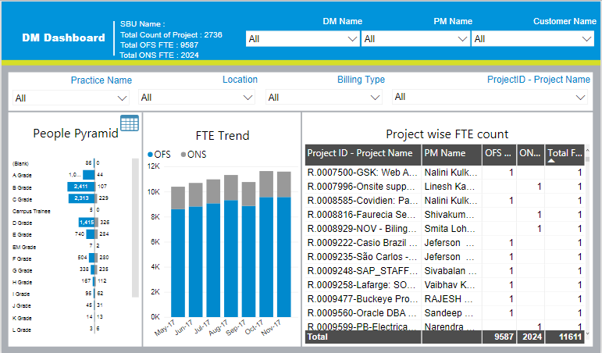

1. Visa

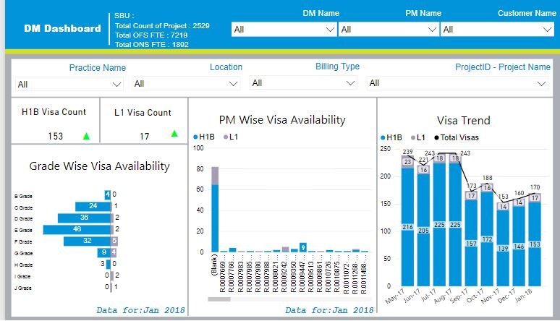

1. Attrition

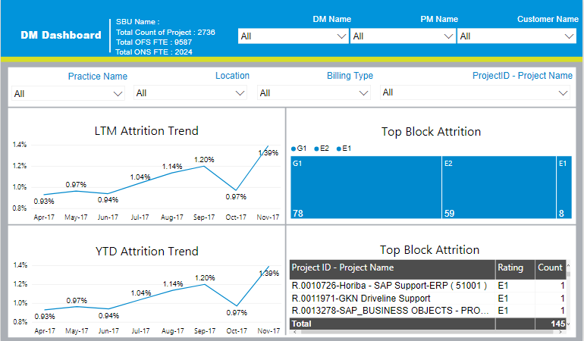

1. Base Data

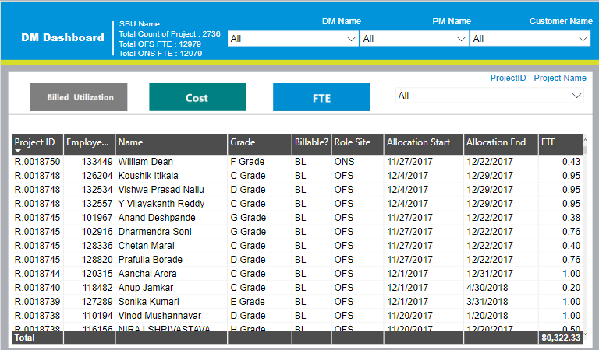

1. FAQ

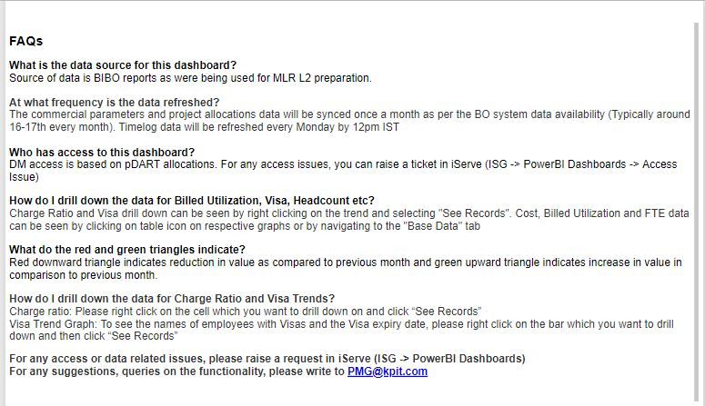

1. Summary Page (Review is pending)

